**Profile EMBARGOED Thursday, April 17, 2014**

**“Dr Deb” Mills**

**MBBS, ISTM**

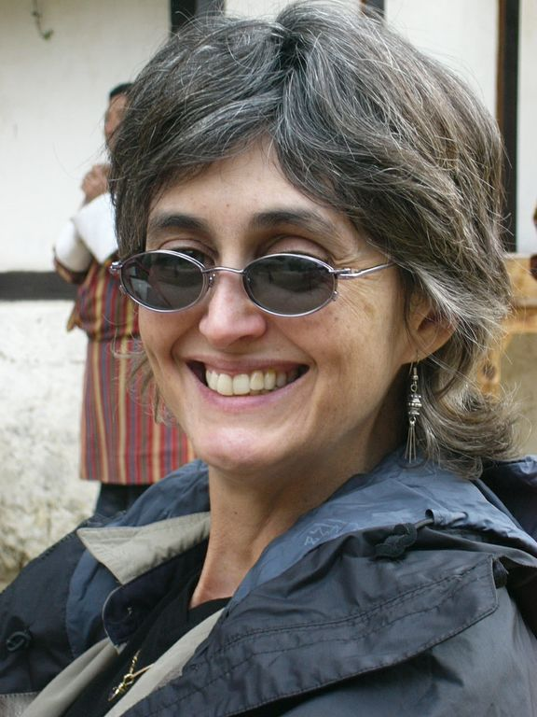Dr Deb Mills is a Travel Doctor, a Queensland pioneer of Travel Medicine and an intrepid traveller, having visited 45 countries world-wide.

“Dr Deb” is also Medical Director of Dr Deb's Travel Medicine Clinics, located in downtown Brisbane and Stafford, and a spokesperson for the Travel Medicine Alliance – a group of independent Travel Medicine Clinics operating nation-wide.

Dr Deb draws on her personal travel experience to ensure travellers receive the critical “been there, done that” information required to travel confidently and make the most of their overseas adventures.

Dr Deb graduated with a Bachelor of Medicine, Bachelor Surgery (MBBS) from Queensland University in 1983. In 2008, Dr Deb gained a Certificate of Knowledge Travel Medicine (ISTM), and has also completed a Post Graduate Certificate of Travel Medicine. She is currently studying a Master of Public Health and Tropical Medicine at James Cook University.

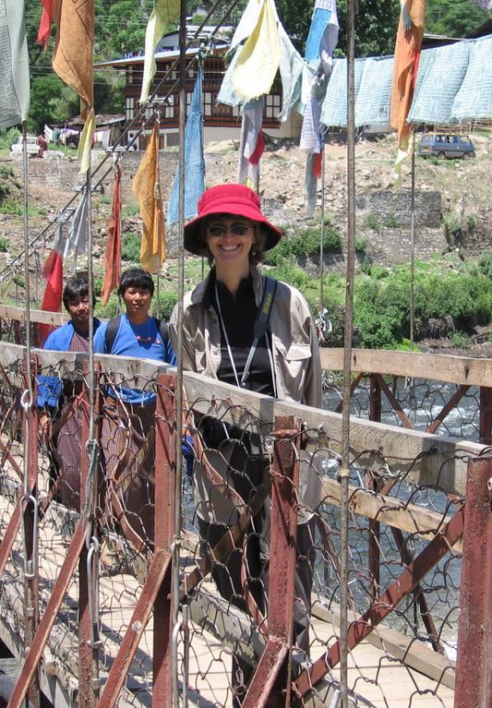

For more than 20 years Dr Deb has been looking after individuals venturing overseas. She also regularly conducts seminars on travellers health for corporate and holiday travellers.

Dr Deb has been widely published in both the medical and consumer media and has published the book *“Travelling Well – The 'must-have' guide to enjoying good health while you travel".*

***ends#***

**To coordinate an interview with Dr Deb Mills, please contact Kirsten Bruce or Ruby Archis from VIVA! Communications on 0401 717 566 / 0413 834 906.**