**Profile EMBARGOED TUESDAY, NOVEMBER 12, 2013**

**Michael, 20**

**First-time traveller to Bali fell victim to unprovoked monkey attack**

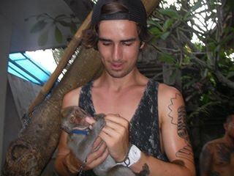

**A visit to a monkey forest in Kuta, Bali, put former Gold Coast resident, Michael, 20 at risk of contracting a potentially fatal infectious disease following an unprovoked monkey attack.**

**The incident may have proven deadly for Michael, had he chosen to ignore his friend’s recommendation to seek professional health advice before travelling to Bali.**

**This is his story.**

It was Michael’s first trip to Indonesia to celebrate the end of high school with his friends. He was looking forward to hanging out at the beach and visiting local bars in Kuta with his mates who had frequented Bali on many surfing trips before.

“I was stoked to go to Bali with my mates. I thought it would be an awesome boys’ trip,” Michael said.

At his friend’s insistence, Michael sought pre-travel health advice two months prior to jetsetting to Indonesia. It was during a local doctor consult that he was warned about the risk of contracting a potentially fatal infectious disease in Bali, and was subsequently vaccinated against hepatitis A and typhoid. His hepatitis B (lifelong vaccine) and tetanus was up to date.

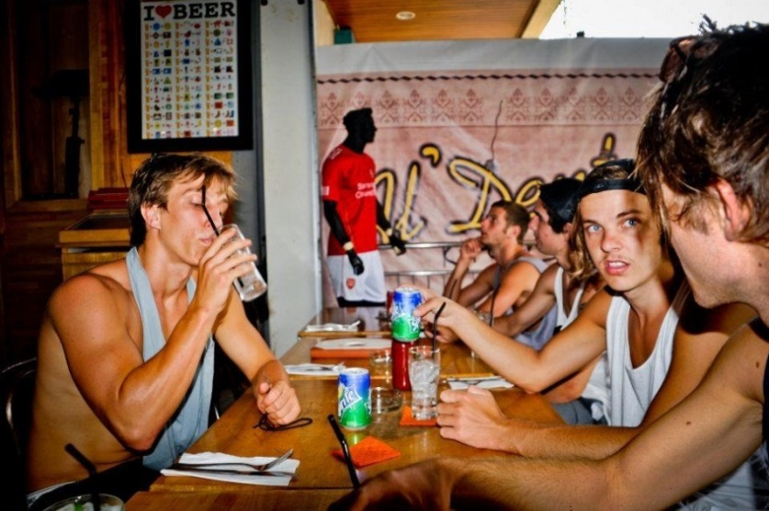“I’m so glad I was vaccinated against various infectious diseases before leaving Australia,” said Michael.

Half-way through their 10-day Schoolies sojourn, Michael and six of his friends hired a tour guide who escorted them to Kedaton Monkey Forest in Ubud.

***more#***

Michael, who had been feeding the monkeys bananas, was sitting on a footpath playing with a shiny lolly wrapper when he was bitten on the back in an unprovoked attack by a large monkey.

“I was sitting about a metre away from the monkey playing with a lolly wrapper. I dropped the wrapper and then the monkey jumped on my back and started hacking into me.

“The monkey may have been aggravated by the glistening silver light of the lolly wrapper,” Michael said.

“His bite didn’t hurt – it was more of a shock.”

According to Michael, what was seriously concerning was the Balinese’s lack of knowledge regarding local health hazards.

“My tour guide didn’t take my monkey bite seriously.

“My mates took snaps of the bite with their phones while my tour guide just wiped the bite, applied an antiseptic cream and covered it with a band-aid,” said Michael.

Because Michael had sought pre-travel health advice well in advance of his trip to Bali, he was adequately protected against various infectious diseases prevalent in Indonesia.

“Fortunately getting vaccinated before heading to Bali helped protect me against contracting an infectious disease,” Michael said.

***ends#***

***­_______________________________________________________________________________***

**To coordinate an interview with Michael, please contact Joni Thomes or Danielle Cesta from VIVA! Communications on 0430 149 642 or 0439 083 869.**