**Profile EMBARGOED TUESDAY, NOVEMBER 12, 2013**

**Helen, 18**

**Schoolie succumbs to lure of South Pacific, *BRISBANE***

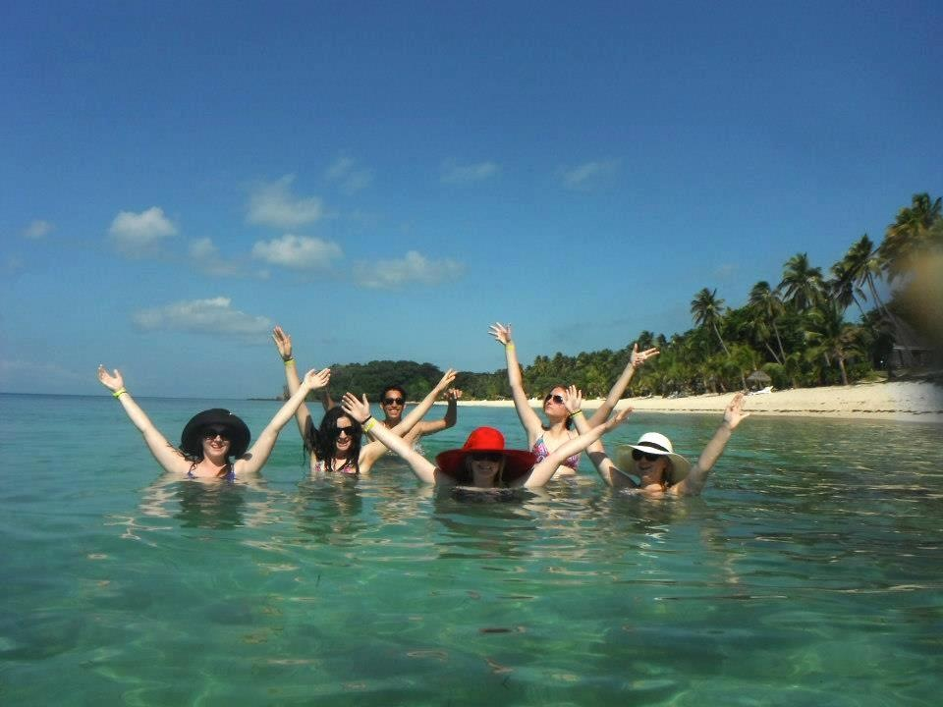**Like many thousands of Schoolies, Brisbane journalism student, Helen, 18 succumbed to the enticing allure of overseas travel to mark the end of her high school studies last year.**

**In November, 2012 Helen set off to Mana Island, Fiji, for a week of partying and frolicking with a group of eight fellow students.**

**This is her story.**

For Helen and her friends, seeking pre-travel health advice was simply not on the radar ahead of their “trip of a lifetime”.

*Helen [wearing white hat] celebrating Schoolies with her friends in Fiji*

“Visiting a travel health clinic or GP was the last thing on my mind when organising my trip to Fiji,” Helen said.

Helen recalls alcohol being the recurrent theme for typical offshore Schoolies celebrations.

“There was a very relaxed approach to alcohol on Mana Island.

“The island had one main bar and another in the middle of the dance floor. There was also a convenience store that sold alcohol,” said Helen.

“What attracted me to Fiji as a Schoolies destination was the fact that it was a safer alternative to the Gold Coast and my parents were happier for me to go there.

“After arriving on the island, I quickly became aware of how easy it was to access alcohol,” Helen said.

“You can’t drink outside Gold Coast apartments. In contrast, alcohol is available early in the morning in Fiji and you can drink anywhere on the island.

“We were given a wristband that would be cut off if a person became too intoxicated. But I only saw that happen on two occasions throughout the week,” said Helen.

Alcohol allegedly represents a strong lure for school-leavers planning to celebrate Schoolies offshore in the new offshore hotspots of Fiji, Vanuatu, Bali, Thailand and Cambodia. ***more#***

“People in the year below me at school wanted to know how great Fiji was as a Schoolies destination because they were thinking of celebrating the occasion there too,” said Helen.

Helen had visited Fiji on many occasions with her family and encountered no health issues. So health concerns figured neither as a concern, nor a priority for Helen in the lead up to and throughout Schoolies, apart from boiling water for drinking purposes, which both her family and GP (whom she had visited for other reasons) had emphasised.

“My doctor had recommended boiling the local water, drinking bottled water (with which I was already familiar), and not leaving drinks unattended,” Helen said.

“I had been considering boiling my drinking water, but having it emphasised to me over and over again by different people helped to reinforce the point.”

According to Helen, the company whom she booked her Schoolies trip through requested evidence of up-to-date tetanus shots. However Helen and many of her friends did not supply this evidence, let alone visit a doctor for any vaccinations at all.

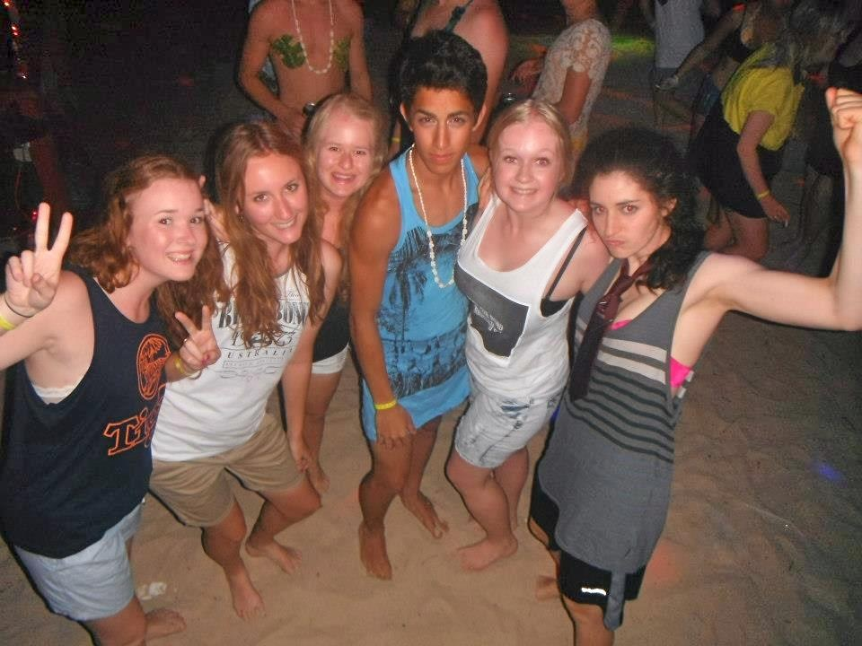“There were various incidents on Mana island involving Schoolies that occurred under the influence of alcohol, including some of her friends who stood on broken glass.”

Helen recalled the shock on her parents faces while recounting the drunken, reckless behaviour of many teenage boys in Fiji.

*Helen [third from left] on Mana Island with friends*

“One night my girlfriends and I were on the ground floor of our two-storey beach villa when we saw a guy go flying over the balcony from the second level of another villa,” said Helen.

“The boys were also having a competition while intoxicated in the pool to see who could hold their breath the longest while swimming laps underwater.

“I realised just how easily you could miss a friend having a mishap, like falling unconscious under water while under the influence of alcohol and lots of noise,” said Helen.

***ends#***

**For more information, or to coordinate an interview with Erin, please contact Joni Thomes or Danielle Cesta from VIVA! Communications on 0430 149 642 or 0439 083 869.**