**Profile EMBARGOED TUESDAY, NOVEMBER 12, 2013**

**Brittany Fowler, 19**

**Health not a priority for travelling Schoolie, *BRISBANE***

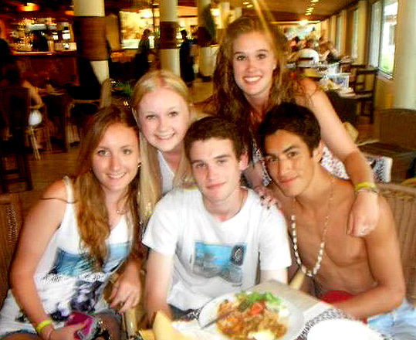**Engineering student, Brittany Fowler, 19, Brisbane, opted for Mana Island, Fiji for her Schoolies destination last year.**

**However the last thing on her mind was contracting a potentially fatal infectious disease while celebrating Schoolies offshore with a close-knit circle of friends.**

**At her mother’s insistence, Brittany visited her local doctor for appropriate vaccinations prior to travelling to Fiji.**

**This is her story.**

“I ended up travelling to Mana Island, Fiji to celebrate Schoolies, as I’d left my run too late to organise a trip to the Gold Coast,” Brittany said.

*Brittany [standing top right] with friends in Fiji*

“One of my friend’s had suggested Fiji as one of three exotic Schoolies destinations.

“My mum was opposed to me travelling to Bali, given the Bali bombings and reported drug use associated with Schoolies. So we settled on Fiji, which was also close to home,” said Brittany.

Brittany’s friend organised the celebration through a company specialising in overseas group travel packages for school-leavers.

“The trip was specifically tailored to Schoolies. The travel crew were fully prepared for the arrival of massive groups of Schoolies ranging from between 200-to-300 people at a time,” Brittany said.

“After arriving on the island, we were asked for our age and ID,” said Brittany.

Brittany has fond memories of her time on Mana Island, celebrating the end of school with her best friends, and claims she would do it all over again.

“There were DJs, dance floors and water activities – all of which were included in our travel package.

“I did some snorkelling and kayaking, but most of my friends just lay by the pool drinking for most of the day,” Brittany said.

***more#***

Brittany also joined an adventure tour of the island, which exposed her to the indigenous culture, lifestyle and educational facilities of the Fijians. While on the tour she was offered native drinks and participated in various activities, including basket weaving.

While the company that organised her Schoolies offshore tour recommended seeking travel health advice a month before departure, for Brittany and most of her peers, health risks were discussed, but not at great length.

“Personally, I would definitely not have considered visiting a doctor before heading to Fiji to protect myself against prevalent infectious diseases, such as hepatitis A and meningococcal disease.

“I think my friends would have been in the same boat,” said Brittany.

“I knew there was a vaccination I had to have by a certain time before travelling to Fiji.

“If I hadn’t been prompted, I would have left visiting my doctor to get vaccinations before flying to Fiji to the last minute,” Brittany said.

“I travel a fair bit with family, but it’s my mother who always takes responsibility for visiting the doctor before heading overseas. Visiting the doctor rarely crosses my mind.

“I wash my hands more as a precaution overseas, but do nothing more than that,” said Brittany.

“Unfortunately, health is simply not a priority for most Schoolies.”

*ends#*

For more information, or to coordinate an interview with Brittany Fowler, please contact Joni Thomes or Danielle Cesta from VIVA! Communications on 0430 149 642 or 0439 083 869.