Profile EMBARGOED: Thursday, Oct 20, 2011

David and Janet Llewelyn, Sydney
Exercising to prevent further fractures

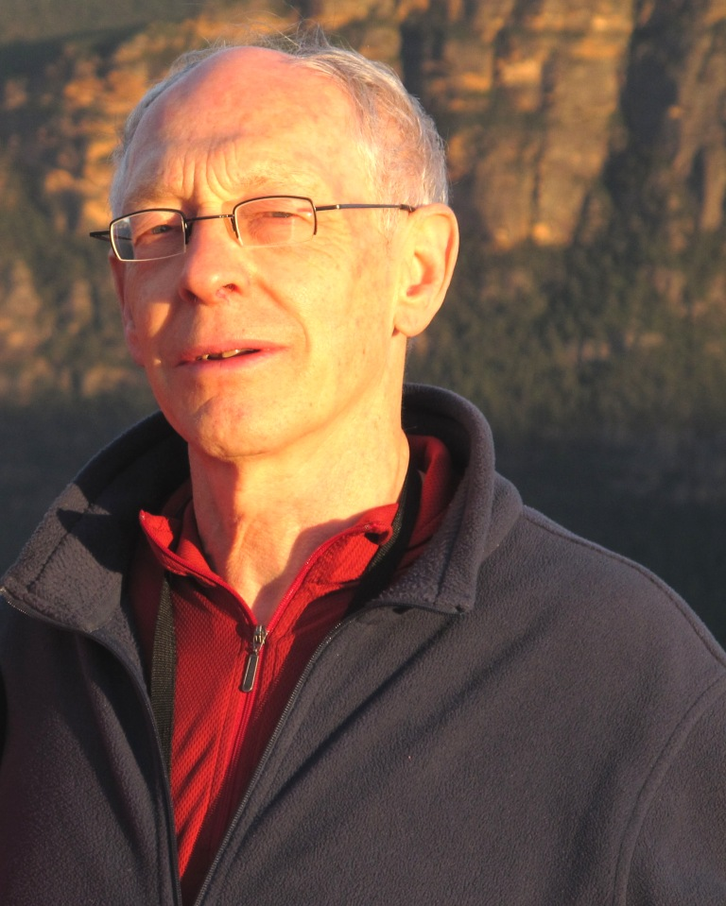
When avid skiers, David, 71, and Janet, 66, were diagnosed in the osteoporotic range, they began a tailored exercise routine to increase their bone strength and flexibility. David and Janet now embrace weekly exercise sessions and a healthy diet to help prevent fractures and to ensure their overall bone health. This is their story.

According to David, prior to his diagnosis there were no signs he was living with osteoporosis. “I had my first bone scan in 2002 following my retirement and I had no symptoms or previous fractures, so I only went to the GP for a general health check-up.

“A bone mineral density (BMD) scan revealed that my hips were in the osteoporotic range. A few years later, I was involved in a skiing accident and I ended up with a fracture of the pelvis. Although the fracture healed, I am now much more cautious of the possible risks associated with brittle bones,” said David.
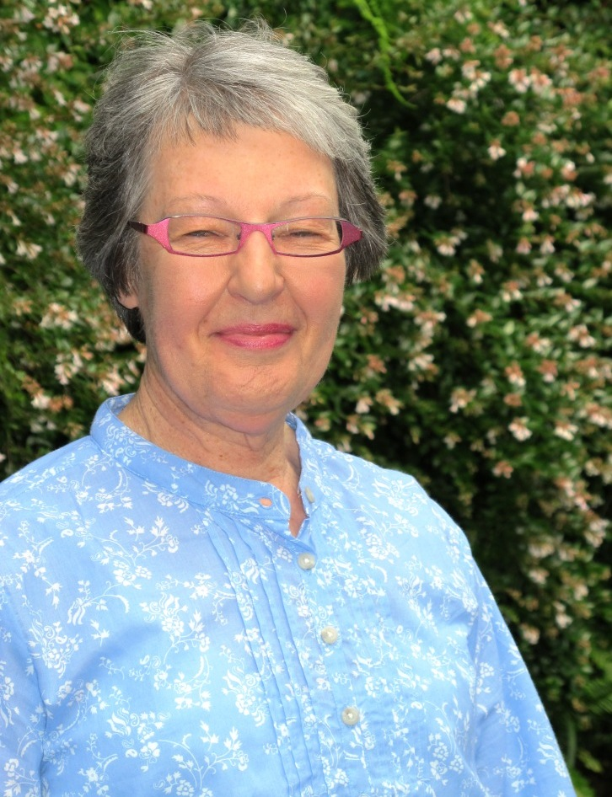
“Janet and I share an exercise session once-a-week with an instructor who incorporates targeted exercises to help increase our bone strength and flexibility.”

In 2000, Janet discovered she was living with osteopaenia, a potential precursor to osteoporosis, in her hip and spine. Janet, also a passionate skier, has not hit the slopes since a skiing accident in the same year left her with a broken arm.

“Although my arm has now healed I haven’t skied since the accident for 11 years, because I want my right arm to be more functional. With regular Pilates sessions, I have improved my range of movement and I have increased flexibility in my hip area.

“Both David and I have increased our bone density marginally since beginning Pilates classes and other exercise routines over the last decade. We attend an over 55’s exercise session once-a-week, run by the Department of Health, which includes an aerobic-style warm up, a balance routine, hand and leg weights and floor-based back stretches,” said Janet.

“We also take calcium and vitamin D supplements, and are both generally more aware of the risk of fracture since being diagnosed with brittle bones.”

ends#

To arrange an interview with David or Janet Llewelyn, please contact Kirsten Bruce or Mahsa Lotfizadeh at VIVA! Communications on 02 9884 9011 or 0401 717 566 / 0422 180 674.

