Profile TUESDAY, JULY 26, 2011
Simone, 38
Facing the possibility of a childless future, Sydney

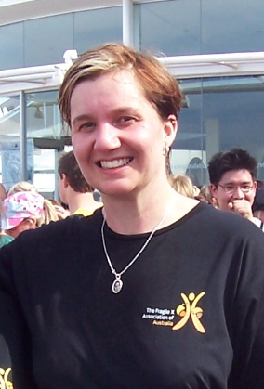
Simone, 38, is a social worker who runs a Sydney-based support service for Fragile X Syndrome (FXS) carriers. After her cousin’s son was diagnosed with a developmental disability three years ago, Simone chose to undergo screening, which revealed she was an FXS carrier – a condition inherited from her mother. Simone now has infertility issues due to FXS. After several failed in vitro fertilisation (IVF) attempts, she is now facing the possibility of a childless future. This is her story.

How and when were you diagnosed with Fragile X?
My cousin’s son was diagnosed with a developmental disorder three years ago, after which the women in my family chose to undergo screening for Fragile X. I was then subsequently diagnosed with Fragile X.

How did you feel when you were diagnosed with Fragile X?
When diagnosed as a carrier of Fragile X, I felt anxious regarding my reproductive options. If I had have been diagnosed earlier in life, for example, as a child through heel-prick testing, then I could have taken the necessary steps as a young adult.

After several failed attempts at IVF, I am now facing the devastating possibility that I may never become a mother. However, because I have been diagnosed with Fragile X, I can now consult fertility experts and avail myself of the technology, which has allowed me to make choices.

Has anyone else in your family been diagnosed with the condition?
My mother went through menopause in her twenties, and at the time, the doctors incorrectly thought this was triggered by a devastating life event. Had they diagnosed her correctly, I would have been tested a lot earlier and potentially avoided my reproductive problems. My Aunty and cousin have also been diagnosed with the condition.

How has Fragile X affected your family?
Although I don’t blame my mother, I do feel upset that I have unwittingly inherited the gene, while other family members are unaffected.

What is your advice to those who may be living with Fragile X?
My advice to people living with Fragile X or carriers of the condition, is to arm themselves with information. The ramifications of diagnosis often spread beyond the individual to include many family members, so it’s important people make informed decisions. I would recommend speaking to a genetic counsellor for support and information.

How important is screening for Fragile X?
I would strongly urge anyone with a family history of intellectual disability or early menopause to talk to their GP about having a genetic test for the condition. It takes about three generations for the fault on the gene to expand to a full mutation. If I had known earlier that I was a carrier of Fragile X, I could have started IVF earlier and may have had more success with conception.
ends#

To arrange an interview with Ms Simone Zaia, please contact Denise Vrontas or Kirsten Bruce at VIVA! Communications on 02 9884 9011 or 0414 524 383 / 0401 717 566.

