Profile EMBARGOED: FRIDAY, Sept 30, 2011

Kathy Divine
Pursuing a healthy lifestyle with osteoporosis, SYDNEY

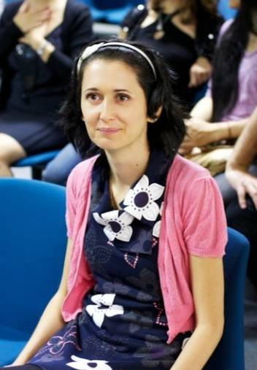
Author, animal lover and avid soccer player, Kathy Divine, 35 was diagnosed with osteopenia in her mid-20s, a condition brought on by eight years of steroid use prescribed for another medical condition. Kathy has broken her wrist twice during a soccer game and has sustained other fractures, including a broken toe. Kathy’s most recent bone mineral density (BMD) scan revealed her condition had progressed, and she is now living with osteoporosis. Due to her fragile bones, she is no longer allowed to participate in any contact sports, including soccer. This is her story.

Kathy was diagnosed with osteopenia in her mid-20s after her doctor chose to screen her for the condition since it was a known side-effect of long term steroid-use.

According to Kathy, “I was on steroids for 8 years, but I didn’t realise the detrimental effect on my bones until my doctor performed a BMD scan.

“I try to follow a healthy lifestyle, but unfortunately I couldn’t do anything to stop it progressing to osteoporosis, which my latest scan revealed,” says Kathy.

Before being diagnosed with osteopenia, Kathy broke her wrist twice playing soccer and her left elbow. “The fact that I had three breaks before diagnosis was possibly a warning sign that I was in the high risk category for brittle bones,” says Kathy. “My lifestyle is now severely restricted – I can’t play any contact sports, and I must limit my physical activities so I don’t break any more bones.

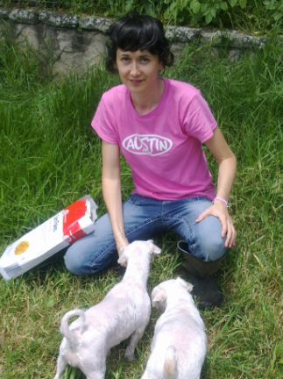
“Regrettably, I can no longer play soccer, apart from just kicking a ball around with a friend and being really careful. I really miss participating in competitive games. I also used to skateboard but I can’t do that now in case I fall over.”

Kathy has recently published Forever 21, an “empowering guide to reclaiming youth, beauty, health, happiness and spirituality.”

Kathy ensures she gets plenty of calcium from her diet. “I follow a very healthy diet and ensure I get plenty of natural vitamins and minerals. I also get just enough sunshine to keep my vitamin D levels up, which helps to manage my osteoporosis.

“I recommend those who are taking steroids, have a family history of osteoporosis, or have sustained multiple fractures, to talk to their doctor about options for managing the disease,” says Kathy.

“Sometimes doctors don’t have sufficient time to go through every single facet of a person’s medical history, which can lead to a patient missing out on vital testing. It’s up to the individual to request appropriate tests for osteoporosis, if they think they’re at risk.”

ends#

To arrange an interview with Kathy Divine, please contact Kirsten Bruce or Denise Vrontas at VIVA! Communications on 02 9884 9011 or 0401 717 566 / 0414 524 383.

