Profile EMBARGOED: THURS, OCT 20, 2011

Professor Rebecca Mason

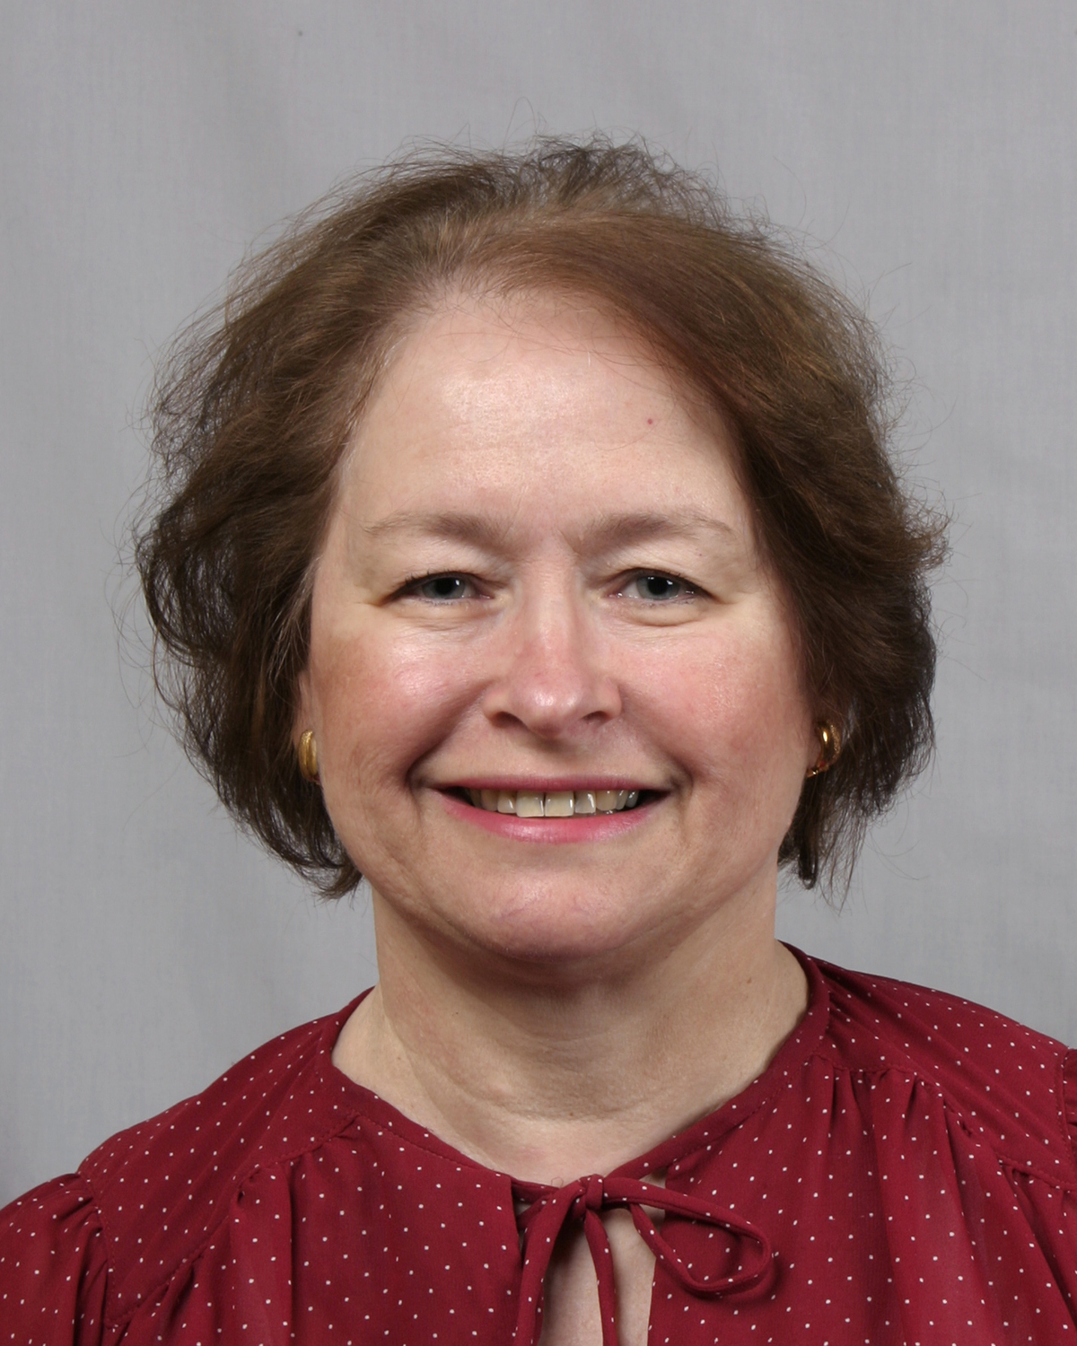
Professor Mason is Head of Physiology and Deputy Director of the Bosch Institute, University of Sydney, a Board Member of Osteoporosis Australia and Immediate Past President of the ANZ Bone and Mineral Society.

She is also serves on the Editorial Board of the Journal of Bone and Mineral Research, is a member of the International Commission on Illumination’s technical committee on Sunlight, Health and Vitamin D and the Cancer Councils of Australia Working Party on Sun and Health.

Professor Mason’s research interests include health aspects of vitamin D, particularly the mechanisms which regulate calcium and phosphate concentrations and bone mass.

In 2009, she received an award from the 14th International Workshop on Vitamin D for “career contributions to vitamin D research”.

ends#

To coordinate an interview with Professor Rebecca Mason, please contact Kirsten Bruce or Mahsa Lotfizadeh from VIVA! Communications on 02 9884 9011 or m. 0401 717 566 / 0422 180 674.

