Profile EMBARGOED: Thurs, Oct 20, 2011

Professor Michael Kimlin BSc MSc GradDipEd PhD
Sun and vitamin D expert, Brisbane

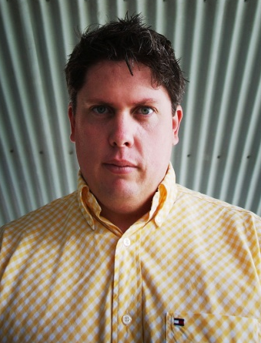
Director of the Australian Sun and Health Research Laboratory (AusSun), Professor Michael Kimlin has a distinguished international career as a skin cancer, ultraviolet (UV) light and vitamin D expert.

Prof Kimlin and other researchers at AusSun, based at the Queensland University of Technology’s School of Public Health in Brisbane, are working to uncover how much sun exposure is needed and how much is too much.

After four years research at the University of Georgia in the United States, he returned to Australia in 2004 and was appointed Director of AusSun. Prof Kimlin was one of the first scientists to be awarded a Queensland Government Smart State Fellowship.

Prof Kimlin’s earlier work concentrated on the dangerous effects of exposure to the sun. But in recent years he has moved his attention to the little known area of vitamin D deficiency.

“We began with the belief that the sun is bad - it causes skin cancer - but now we are finding we might have got that wrong in so much as a lack of sunlight can be just as dangerous for human health,” Prof Kimlin said.

Prof Kimlin's research has attracted significant funding, including the largest National Health and Medical Research Council (NHMRC) grant ever received at QUT, and his research also received funding from the prestigious United States National Cancer Institute.

Prof Kimlin’s work has been described as “internationally important” and has considerable potential to develop better preventative health strategies and to improve our knowledge of disease risk for a number of diseases including cancer.

But little is yet known about the amount of sunlight needed to promote human health and this is a major area of interest currently being examined at AusSun.

This work has culminated in the award in late 2010 of a NHMRC Center for Research Excellence in Sun and Health (CRESH). This Center is investigating the health duality of sunlight exposure. CRESH Co-investigators include Professor Peter Ebeling (UoM), Cancer Council Australia, Cancer Council Queensland, ANU, QIMR and Griffith University.

"There is a high level of awareness in the population about the dangers of the sun, especially in Queensland,” Prof Kimlin said. “But for some people - underground miners, long-haul flight crews, shift workers, and perhaps indoor workers - there is very little awareness of the healthy benefits of sunlight exposure.”

ends#

To arrange an interview with Prof Kimlin, contact Kirsten Bruce, Kirsty Noffke or Mahsa Lotfizadeh at VIVA! Communications on 02 9884 9011 / 0401 717 566 / 0401 090 089 / 0422 180 674.

