
Consumer backgrounder EMBARGOED THURS, OCT 20, 2011

About osteoporosis & osteopaenia

About osteoporosis
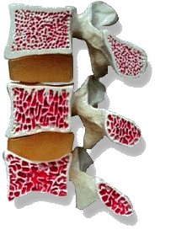
- Osteoporosis is a disease that leads to reduced bone strength and increased risk of fracture, particularly of the spine, hip and wrist^{1,2}
Normal bone

Osteopaenic
bone

Osteoporotic
bone
© University of Arizona Extension Center
- Osteoporosis occurs when bones lose their density and quality, leading to weakness of the skeleton³
- Osteoporosis is often referred to as the “silent disease” as it usually has no obvious signs or symptoms, and is often only diagnosed after a fracture occurs³
- Almost any of the body’s 206 bones can be affected by osteoporosis, however fractures most often occur in the hip, spine, wrist, ribs, and pelvis.¹

About osteopaenia
- Osteopaenia is a condition of low bone mineral density (BMD) and is considered a potential precursor to osteoporosis⁴
- Osteopaenia is defined as a BMD T-score between -1.0 and -2.5⁴
- Not every person diagnosed with osteopaenia will develop osteoporosis⁴
- People with osteopaenia should be assessed for risk of osteoporosis and consider taking steps towards building better bone health.⁴

Prevalence of osteoporosis and osteopaenia
- Osteoporosis is a global health problem, estimated to affect more than 150 million people worldwide⁵
- In Australia, osteoporosis is a National Health Priority affecting more than 1.2 million Australians⁶
- Almost 6 per cent of men and 23 per cent of women over the age of 50 are living with osteoporosis⁶
- 5.4 million Australians are living with osteopaenia⁶
- While osteopaenia is more prevalent than osteoporosis among women aged 55-to-79 years, osteoporosis dominates among those over 80 years of age (51 per cent vs 43 per cent, respectively)⁶
- One-in-two (56 per cent) men aged over 50 years is living with osteopaenia, while 18.5 per cent of men aged over 80 years have osteoporosis.⁶

Risk factors for brittle bones
  - Biomedical and genetic risk factors for osteoporosis include a family history of osteoporosis, low body mass index (BMI), previous minimal trauma fractures and early onset of menopause⁷
  - Lifestyle risk factors include calcium and vitamin D deficiency, smoking, excessive alcohol intake and physical inactivity⁷
  - Medical risk factors include low testosterone levels, being underweight, rheumatoid arthritis, chronic lung or kidney disease and long-term corticosteroid treatment.⁷

Awareness
- There is a need for improved education and awareness about the importance of maintaining strong, healthy bones
- One-in-five respondents to a recent Consumer Tracking Study commissioned by Osteoporosis Australia, could not name a single risk factor for brittle bones⁸
- While the Australian public has a reasonable understanding of calcium’s role in promoting good bone health (49 per cent), only one-in-three study respondents recognised the need for regular exercise and just 7 per cent cite vitamin D/sunshine as being important.⁸
more#

About fractures
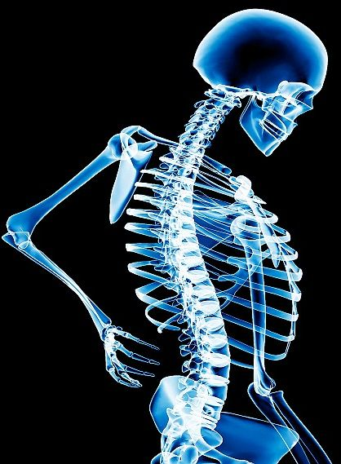
- Osteoporotic fractures can lead to changes in posture (e.g. developing a ‘round back’), muscle weakness, loss of height and deformity of the spine¹
m382448 [RM] © www.visualphotos.com

- In Australia, one-in-two women and one-in-three men over the age of 60 years will experience an osteoporotic fracture³
- Every five-to-six minutes an Australian is admitted to hospital with an osteoporotic fracture. This is expected to rise to every three-to-four minutes by 2021³
- In 2006 and 2007, 51,000 Australians aged 40 and above were hospitalised with a minimal trauma fracture.¹ Of these, almost half were from hip fractures¹
- The number of Australians sustaining a hip fracture is expected to increase four-fold by 2051.³

About the ‘cascade effect’
- The ‘cascade effect’ refers to the increase in risk of further fractures occurring with each new fracture⁹
- People who have sustained a spinal fracture are four times more likely to experience another fracture within 12 months compared with someone who has never sustained an osteoporotic fracture¹⁰
- Women who have had two or more osteoporotic fractures are up to nine times more likely to have another fracture, rising to an 11 times greater risk for women who have had three or more fractures, compared with someone who has not broken a bone⁹
- Only 40 per cent of women who report having been diagnosed with osteoporosis perceive themselves to be at a higher risk of fracture than healthy women (those who have not been diagnosed with osteoporosis) of the same age¹¹
- People at a heightened risk of osteoporosis may be unaware that risk factors including a prior fracture, family history of fracture, low weight, smoking, early menopause and high alcohol intake increase their risk of further fracture¹¹
- Less than one-in-four people who have experienced an osteoporotic fracture are on specific medication to reduce their risk of further fracture³
- Proper investigation and management of osteoporosis could reduce the risk of refracture by 80 per cent.¹²

Morbidity and mortality
- Fractures are associated with approximately 2,500 deaths in Australia each year¹
- Hip fractures often have the most severe consequences in terms of ongoing pain, disability and mortality²
- Following a hip fracture in Australia, one-in-four patients die within 12 months, one-in-four patients will remain in a nursing home for the rest of their lives and one-in-two will never regain their pre-fracture mobility³
- Two-thirds of vertebral fractures (fractures of the spine) are not identified or treated, even though they nearly all cause pain and some disability.⁹

Quality of life
- The burden of osteoporosis not only affects those living with the disease, but their family, friends and the community¹
- The effects of osteoporosis on quality of life include chronic pain, disability, emotional distress, loss of independence, lost productivity, reduced social interaction, self-limitation caused by a fear of falling and the ongoing costs of management and treatment.¹

more#

Economic burden
- The direct cost of osteoporosis is approximately $1.9 billion annually³
- The indirect costs associated with osteoporosis, including loss of productivity, lifestyle modification costs, travel costs and lost quality of life, inflate Australia’s total annual cost of the disease to more than $7 billion.⁵

Prevention
- Lifestyle changes that may reduce the risk of developing osteoporosis include not smoking, limiting alcohol consumption, ensuring adequate calcium intake and exposure to sufficient vitamin D/sunshine⁷
- Regular exercise helps to strengthen bones and prevent falls and fractures.¹³

Treatment
- Through early identification of people who are at risk of low bone density, simple steps can be taken to improve bone health¹
- Treatment for osteoporosis focuses on alleviating symptoms, optimising function, minimising the impact of disability and maximising quality of life, preventing falls¹ and reducing the risk of further fractures¹²
- Early diagnosis and prompt treatment may help minimise pain and physical limitation and slow the progression of osteoporosis¹
- Osteoporosis is generally managed with regular weight-bearing exercise and a balanced diet rich in calcium, in addition to medication and vitamin D/sunshine or supplements.¹

ends#

For more information about osteoporosis or osteopaenia, visit www.osteoporosis.org.au, or contact Kirsten Bruce or Mahsa Lotfizadeh from VIVA! Communications on 0401 717 566/ 0422 180 674 / 02 9884 9011.

References
- Australian Institute of Health and Welfare (AIHW). Arthritis and osteoporosis in Australia. Cat No PHE 106. Canberra. December 2008.
- Australian Institute of Health and Welfare. Australia's health 2010. Cat. no. AUS 122. Canberra: AIHW.
- The burden of brittle bones – epidemiology, costs & burden of osteoporosis in Australia. Prepared by Department of Medicine, The University of Melbourne, Western Hospital, Footscray, Victoria, for Osteoporosis Australia. 2007.
- National Osteoporosis Foundation (NOF). Osteopenia: What does it mean? 2011. [http://www.nof.org/aboutosteoporosis/detectingosteoporosis/ osteopaenia] Last accessed on September 26 2011.
- The Burden of Brittle Bones: Costing Osteoporosis in Australia. Prepared by Access Economics Pty Ltd, Canberra, ACT for Osteoporosis Australia. 2001.
- Henry MJ, Pasco JA, Nicholson GC, Kotowicz MA. Prevalence of osteoporosis in Australian men and women: Geelong Osteoporosis Study. MJA September 19, 2011; 195 (6): 321-322.
- Osteoporosis Australia. Risk Factors 2011.
- Osteoporosis Australia. GP and Consumer Tracking Study. May, 2011.
- Osteoporosis Australia. What is Osteoporosis? 2011.
- Arthritis Victoria. Prevent the next fracture. GP guide. Prepared by Osteoporosis Australia. 2006.
- Siris ED., et al. Failure to perceive increased risk of fracture in women 55 years and older: the Global Longitudinal Study of Osteoporosis in Women (GLOW). Osteoporosis Int 2011; 22: 27-35.
- Lih A., et al. Targeted intervention reduces refracture rates in patients with incident non-vertebral osteoporotic fractures: a 4-year prospective controlled study. Osteoporosis’ Int 2011; 22: 849-858.
- Osteoporosis Australia. Preventing osteoporosis 2011.

