PROFILE Tuesday, July 26, 2011
Nicola, 45
Managing Fragile X through early intervention

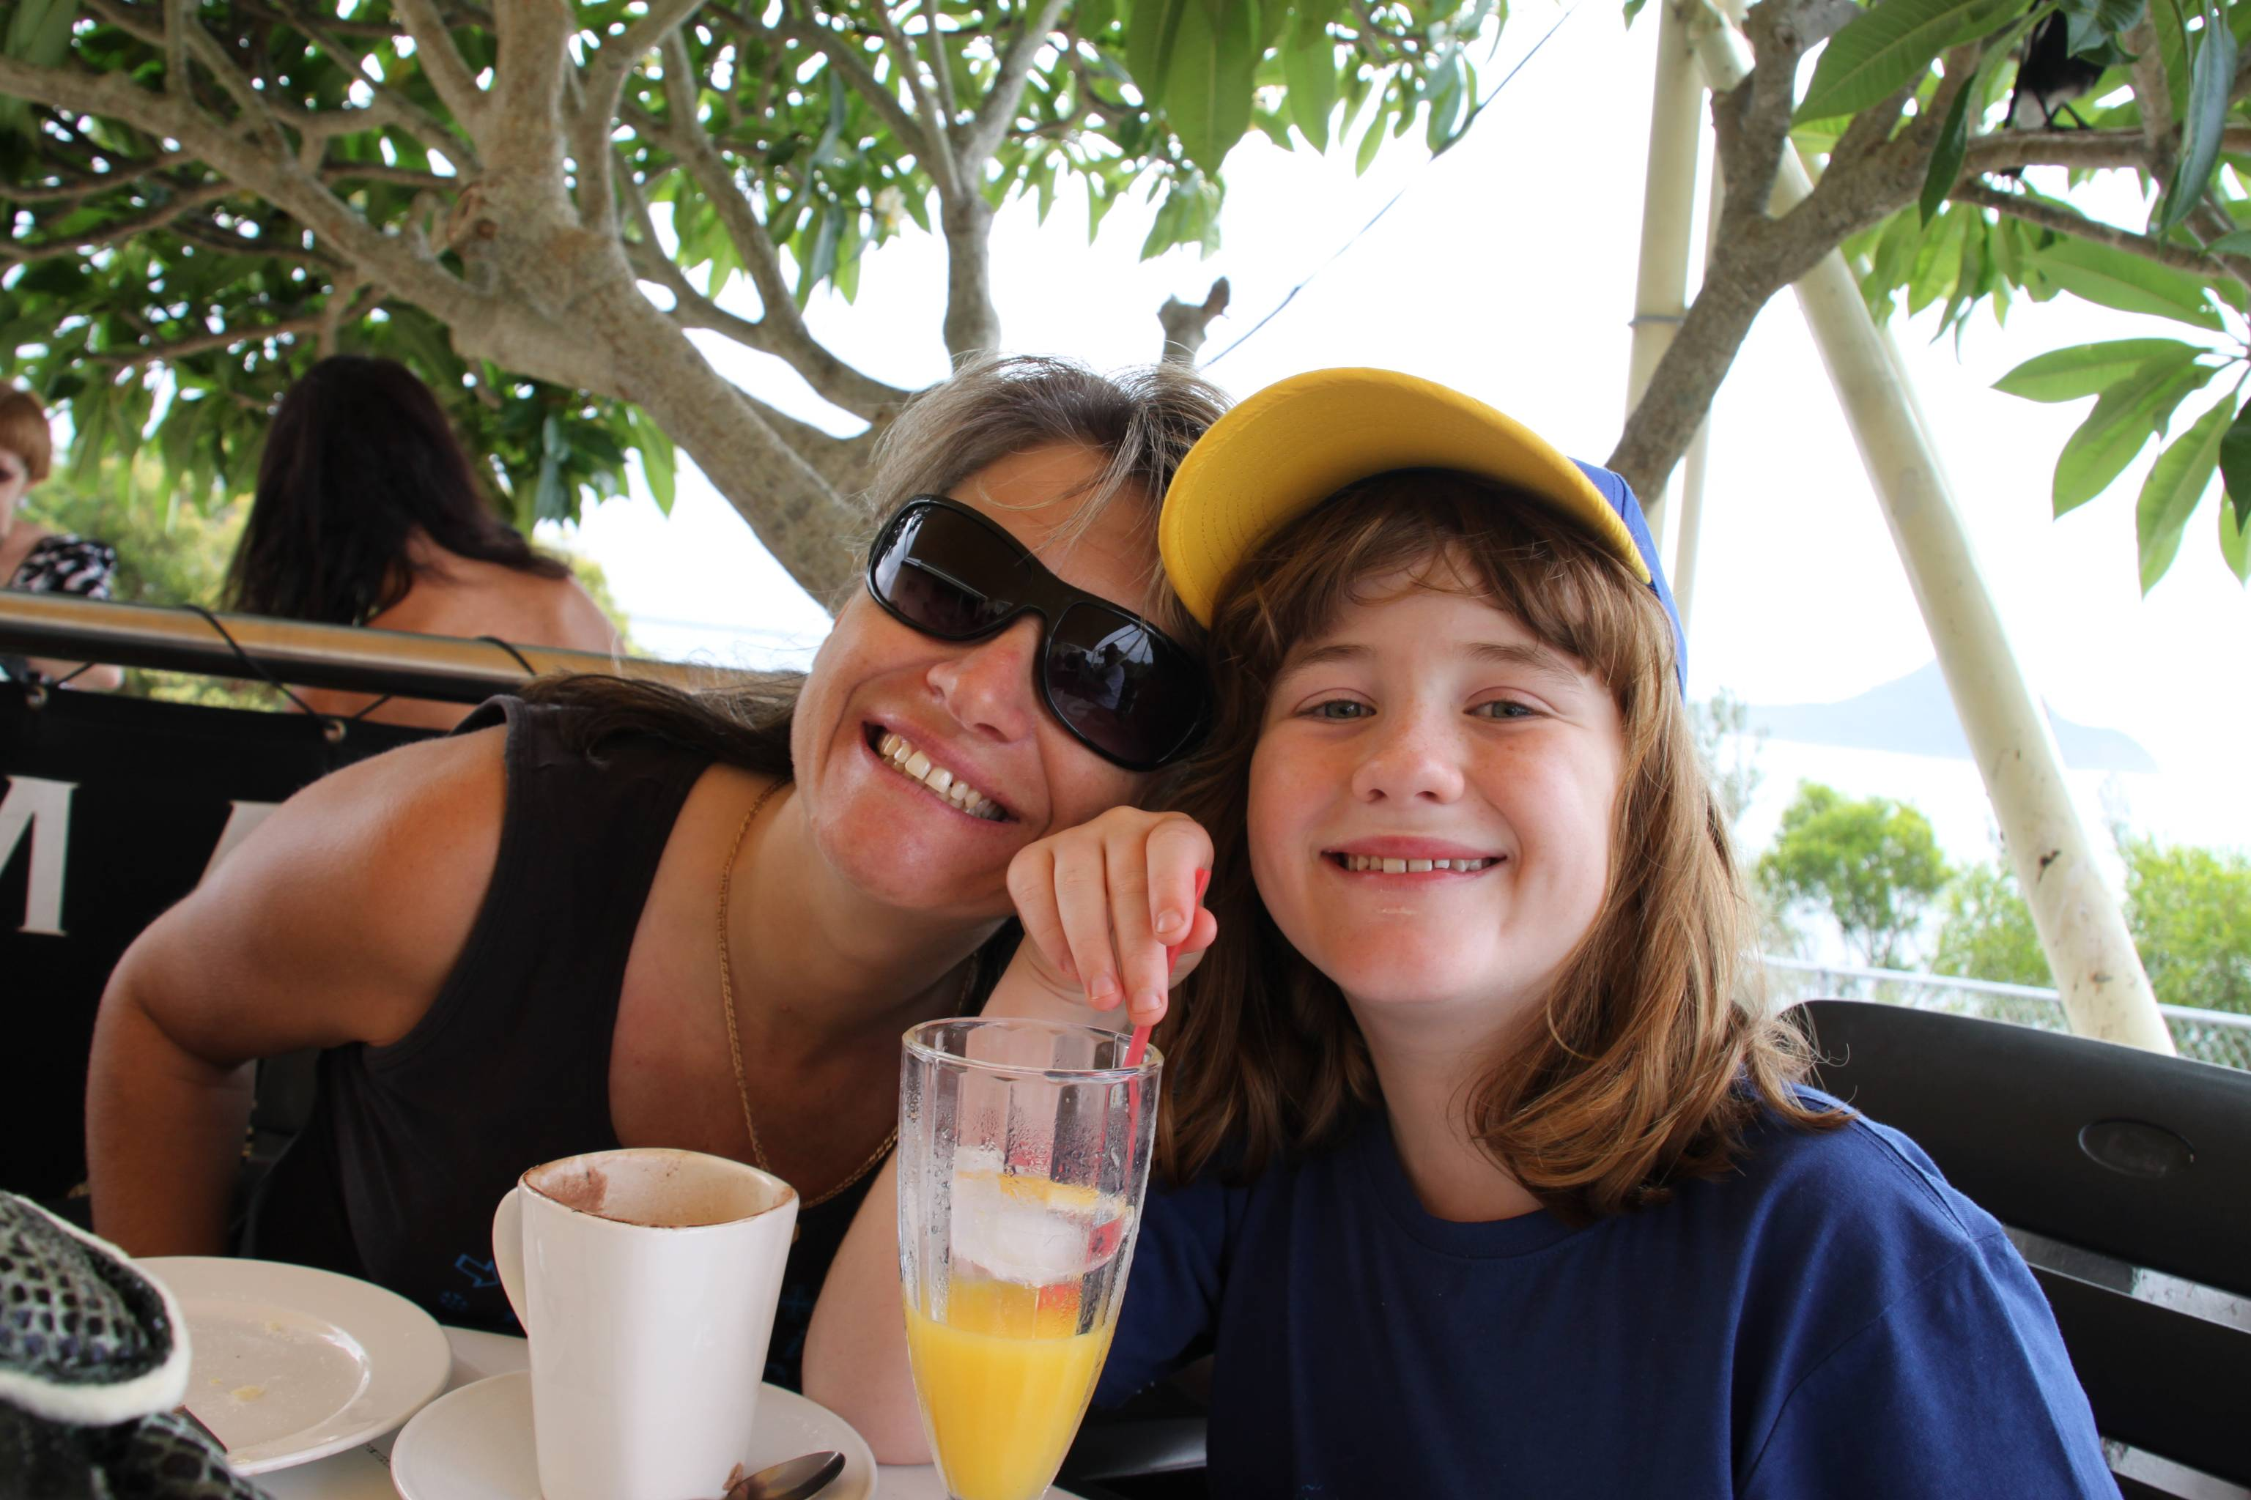
Mother of four, Nicola, 45, from Asquith, Sydney has a family history of Fragile X and is a carrier of the Fragile X gene. The condition was left undiagnosed in Nicola’s immediate family, including her younger brother and sister, until she recognised some of the symptoms in her eldest daughter, Maddie, 12, who was diagnosed with Fragile X at two years of age. Fortunately Maddie’s early diagnosis gave her access to specialised care from a very young age. Continuing support from family members, healthcare professionals and support networks has helped to manage Maddie’s condition. This is their story.

When were you diagnosed with Fragile X?
Nicola with her daughter, Maddie

As a child, I was highly anxious and very introverted, but was not diagnosed with Fragile X. It wasn’t until I noticed some developmental problems with my first child, Maddie, that I considered discussing the possible causes with my doctor.

When Maddie, who was two years old at the time, was diagnosed with Fragile X, I also discovered that I was a carrier of the Fragile X gene. Following Maddie’s diagnosis, my younger brother and sister – who had also displayed Fragile X symptoms throughout their lives – were prompted to get tested, and were subsequently diagnosed with full mutation Fragile X.

What factors prompted you and your daughter to get tested for Fragile X?

I first recognised there was something different about Maddie at mother’s group, as she was developing at a much slower pace compared to the other children. While the other children were crawling and learning to walk, Maddie just couldn’t keep up. When she eventually began to sit up and try to walk, she had very limited upper body movement. She was unable to eat solid foods, so we pureed her meals until the age of two. That’s when I started to become very worried. My GP referred me to a local paediatrician who instantly recognised the symptoms and suggested a blood test for Fragile X.

How did you feel when you and your daughter were diagnosed with Fragile X?

At first, there was just so much information to absorb about the condition, so we decided to take it one step at a time. While we had a family history of Fragile X, we were all unaware what the diagnosis would mean for us, and for Maddie.

We started researching the condition, and received a host of information from our paediatrician and other specialists to improve our understanding of the condition. Our paediatrician referred us to a Fragile X specialist at the Royal North Shore Hospital (RNSH), Sydney, who explained the prognosis and provided recommendations for managing the condition.

All the information and advice pointed to early intervention, so we made sure that Maddie received specialist care from an early age. We took her to the Chatswood Assessment Centre in Sydney, and absorbed advice from doctors, speech therapists, physiotherapists, and occupational therapists, to help us manage Maddie’s condition.
more#

How has Fragile X affected you and your daughter?

Over the past couple of years, I’ve noticed some small changes to my condition, including little hand tremors, memory loss, and a loss of balance.

For Maddie, the experience has been challenging, but we are managing her condition well. When she was a toddler, we were introduced to an early intervention group called LifeStart. The LifeStart program was designed to prepare children with disabilities, including Fragile X, for primary school and mainstream classes.

While Maddie sometimes talks to herself, and has problems communicating with her peers at school, she appears to be fitting in quite well and is preparing to enter high school next year.

How has Fragile X affected your family?

In the beginning, we found it beneficial to follow a set routine so that Maddie felt comfortable in her surroundings. If we broke with routine, Maddie would become quite distressed. As we had more children, it became much harder to follow a routine, especially during family holidays. When Maddie was seven years old she became distressed during a family holiday, so we this put an end to our family holidays. We have since bought a caravan so that Maddie can get comfortable in her own space and set her own routines.

What is your advice to those who may suspect they have Fragile X, or have a family member with the condition?

I highly recommend that those who suspect they may have Fragile X or have a family member with Fragile X, see their GP to undergo relevant testing and to get a proper diagnosis. From there, it is important to read plenty of information on the condition, get up-to-date advice from a Fragile X specialist, and to consider early intervention programs.

How important is generating awareness of Fragile X?

One of the most challenging aspects of the condition is explaining Fragile X to health professionals.. While some clinicians have heard about Fragile X through their medical training, many have not seen a patient with the condition. To ensure that other families do not have to endure what I have experienced, healthcare professionals and the community require greater education on the condition.

ends#

For more information, or to coordinate an interview with Nicola, please contact Denise Vrontas or Kirsten Bruce at VIVA! Communications on 02 9884 9011 or 0414 524 383 / 0401 717 566.

