Profile EMBARGOED Thurs, Oct 20, 2011

Professor Robin Daly PhD, FASMF

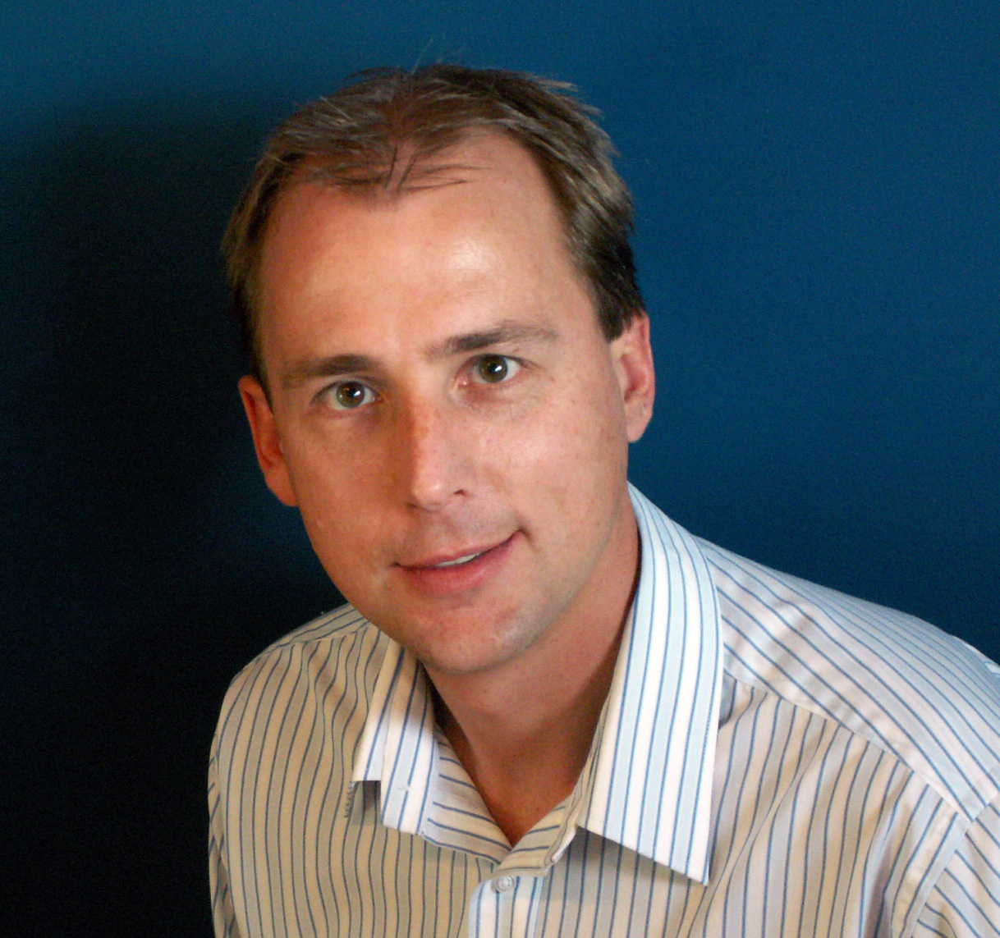
Professor Robin Daly is the Chair of Exercise and Ageing within the Centre for Physical Activity and Nutrition Research at Deakin University, Melbourne.

Professor Daly is recognised internationally for his research into the role of exercise and nutrition for optimising musculoskeletal health during growth and ageing, and preventing chronic diseases such as osteoporosis and sarcopenia.

His research expertise includes conducting large and complex clinical intervention and health promotion trials; using cutting-edge imaging modalities (MRI and CT) to assess the effects of exercise and diet on body composition, bone micro-architecture and bone strength; and health issues related to vitamin D deficiency and chronic low-grade systemic inflammation.

He has published one book, 10 book chapters and invited reviews and more than 65 peer-reviewed scientific papers. He has also presented or co-authored more than 120 papers at national and international scientific meetings. He has been awarded over 20 peer-reviewed national and international awards for his research, including the prestigious Lorin Prentice Memorial Award from Osteoporosis Victoria, for outstanding contribution in raising public awareness of musculoskeletal disease.

Prof Daly is a member of the Medical and Scientific Advisory Committee and the Healthy Bones Subcommittee of Osteoporosis Australia, and a board member of Sports Medicine Australia. He was recognised nationally for his contribution to the sports medicine and science field in 2010 when appointed a Fellow of the Australian Sports Medicine Federation.

He currently serves on the editorial board of a number of international journals, including the Journal of Bone and Mineral Research, the Scandinavian Journal of Medicine and Science in Sport and Frontiers in Clinical and Translational Physiology.
ends#

To arrange an interview with Prof Daly, contact Kirsten Bruce, Kirsty Noffke or Mahsa Lotfizadeh at VIVA! Communications on 02 9884 9011 / 0401 717 566 / 0401 090 089 / 0422 180 674.

