Profile EMBARGOED: Thurs, October 20, 2011

A/Prof John Gullotta AM
BMed (Hons), BPharm, FRACGP, FAMA

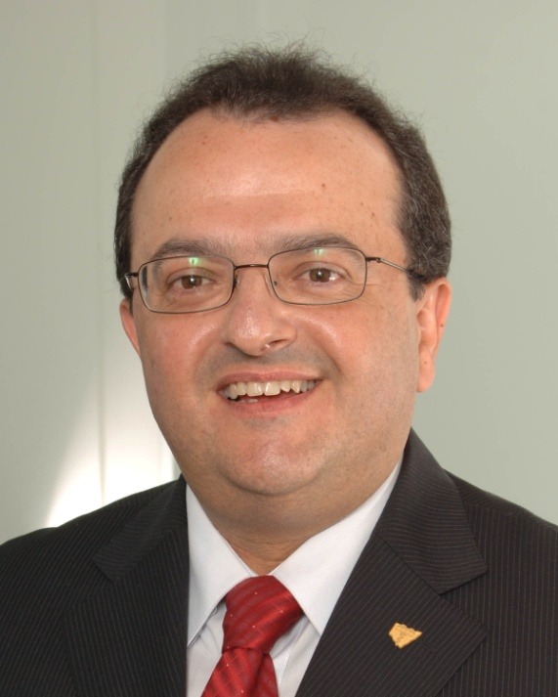
Dr John Gullotta has an extensive involvement in academia, medical organisations, media and community service. He is a GP and clinical teacher at Sydney and NSW Universities, and in 2005 was awarded the title of Adjunct Associate Professor, Central Clinical School at the Sydney Medical School, University of Sydney.

Dr Gullotta is Chair of the Federal AMA Therapeutics Committee. He is also Past President of the AMA (NSW). In 2006 he was admitted to the Australian Medical Association Role of Fellows in recognition of the sterling service and many years of dedication to the AMA.

Dr Gullotta is in full-time medical practice as a General Practitioner in Sydney. He also retains his registration as a pharmacist, and has served on numerous pharmaceutical advisory bodies. He is currently a member of the Poisons Advisory Committee NSW Health, the Medicines Australia Code of Conduct Committee, the Medicines Evaluation Committee of the TGA, and the Advisory Editorial Panel of "Australian Prescriber". His community commitments include Chairman of the AMA NSW Charitable Foundation and membership of Rotary and the Variety Club of Australia.

Dr Gullotta is the recipient of many awards including the Inaugural University of Newcastle Alumni Medal and the University of Sydney 2007 Alumni Award for “Outstanding Achievement in Community Service” for his energetic contributions to medicine, medical education and pharmacy, as well as for his service to the Italian-Australian community in Sydney.

In 2007 he was appointed Member in the Order of Australia, AM for “service to medicine through a range of executive roles with professional medical associations and as a general practitioner, and to the Italian community”.

ends#

To coordinate an interview with Dr John Gullotta, please contact Kirsten Bruce or Mahsa Lotfizadeh from VIVA! Communications on 02 9884 9011 or 0401 717 566 / 0422 180 674.

