Profile EMBARGOED: Fri, Sept 30, 2011

Felicity Doherty, 58
Living with osteopaenia for 20 years, Melbourne

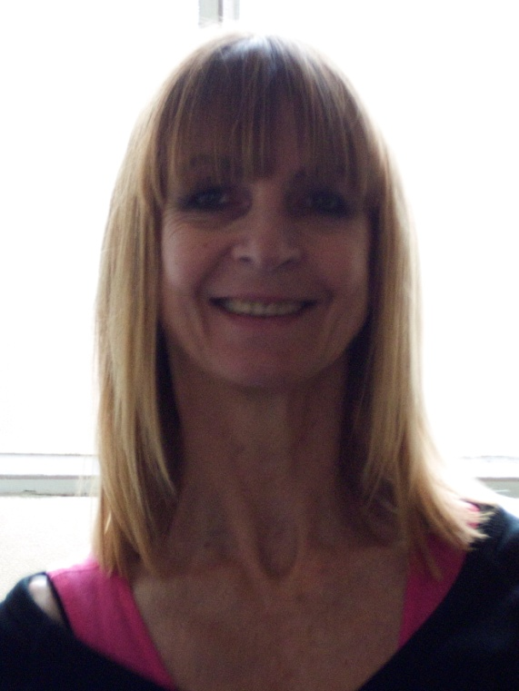
Felicity Doherty was shocked by her diagnosis of osteopaenia in her late thirties. Now 58, the visual and performance artist has continued to dance and has found comfort in yoga. This is her story.

Felicity, also known as Fiz, discovered her brittle bones by accident when she underwent a free bone scan on her wrist for “a laugh and the free cup of tea”.

“I was so shocked, I walked out and fell over on the footpath,” Felicity said. “A hospital bone mineral density scan confirmed I was osteopaenic, but if it hadn’t been for the free scan, I wouldn’t have known for years.”

Felicity has since discovered her mum was diagnosed with post-menopausal osteopaenia, and other factors that may have contributed to the development of her osteopaenia, including taking corticosteroids as a child and not drinking much milk.

“I was working on my feet all day, as a jewellery designer, and I would go home in extreme pain. I had general x-rays done which showed nothing. After about six years I was in absolute agony and I went to my GP in tears. He sent me for a more complex scan which identified the stress fractures.”

Felicity said she has used various treatments, with differing levels of success.

She is studying to become a qualified yoga teacher “Yoga is really good, because it keeps you flexible and energises the body.” and she has continued to dance. “I also do tango now and that’s wonderful. It’s good for the mind and good for the body,” Felicity said.

ends#

To arrange an interview with Felicity Doherty, contact Kirsten Bruce, Kirsty Noffke or Mahsa Lotfizadeh at VIVA! Communications on 02 9884 9011 / 0401 717 566 / 0401 090 089 / 0422 180 674.

